Github link:

https://github.com/Jzheng48/Module-3-Assignment-Data-Access.git

Step 2: Review the sample code before using this code.

Step 3: Watch the video but **do not install the local instance of SQL Server,** only install the extensions：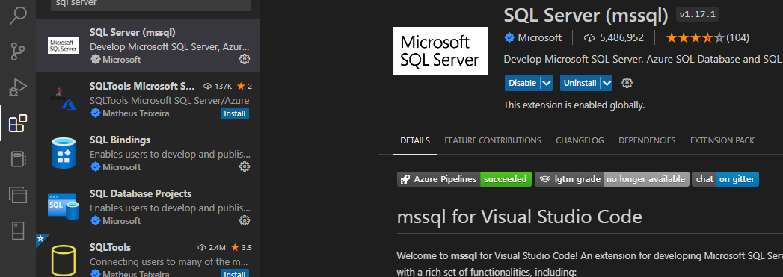

Step 4: Required:

How to connect to a Free Hosted Online SQL Server AdventureWorks Database

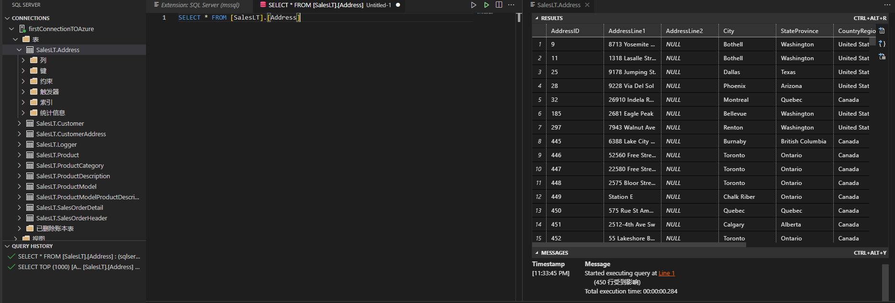

Step 5:**( **Step 3 should be fully functional and tested before continuing with the rest of the assignment steps)**

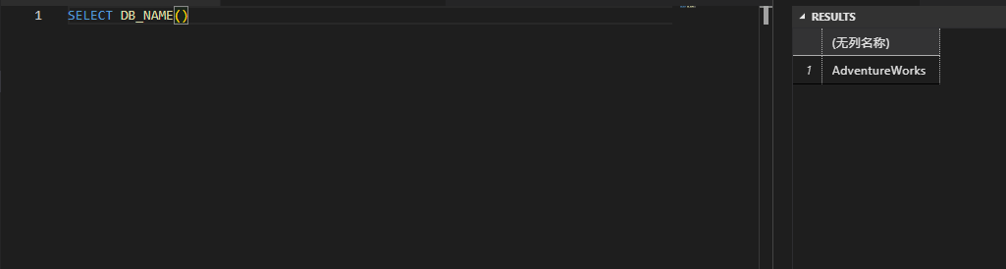

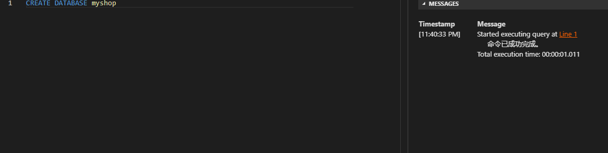

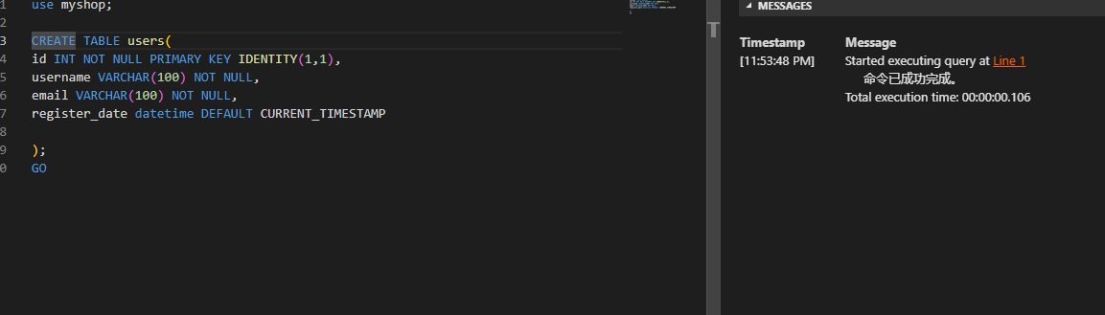

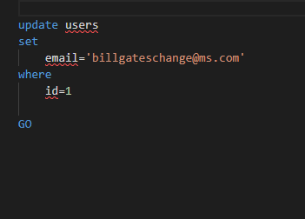

Step 6: Required:

Create a Customers Resources, Routes and Controllers

Use AdventureWorks Database from the Sample Code

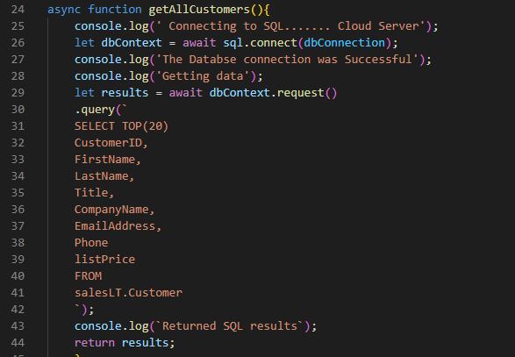

**Additional requirements:**

|  |  |  |
| --- | --- | --- |
| Created Correct Individual SQL SELECT Statement to Query Data in four Tables    Show the SQL Statements that you used to create your Customer list. |  |  |
| Created Correct SQL statements to JOIN Data in more than one table    Show an example of joining two tables using COMPLETE SQL STATEMENTS with related data. |  |  |

